Power BI Retail Sales Analytics Capstone
Day 1 – Data Preparation and Data Modeling
1. Project Overview
The Retail Sales Analytics project aims to analyze sales performance for a fictional multi-region retail company using Microsoft Power BI. The project uses synthetic training data covering the period from 1 January 2023 to 31 December 2025.
The main objective of Day 1 was to import the datasets, inspect data quality, perform initial data preparation, create a Calendar table, and establish relationships between the tables.
2. Data Import
Seven datasets were imported into Power BI using Power Query.
Dataset | Expected Rows
Customers.csv | 1,500
Products.xlsx | 120
Employees.xlsx | 45
Orders.csv | 12,000
Order_Items.csv | 28,641
SalesTargets.csv | 1,620
Returns.csv | 1,239
The datasets were imported separately to make data inspection and transformation easier.
3. Data Cleaning and Quality Checks
Power Query was used to inspect the datasets and check for duplicate keys, blank values, appropriate data types, and unexpected missing values.
Customers table
- Confirmed 1,500 rows.
- Checked CustomerID for duplicates and blank values.
- Inspected other customer fields, including customer name, city, region, segment, and signup date.
- Sorted CustomerID in ascending order in Power BI Table view.
Products table
- Confirmed the expected 120 rows.
- Checked ProductID for duplicate and blank values.
- Inspected product attributes and numeric fields.
- Sorted ProductID in ascending order in Power BI Table view.
Employees table
- Imported the employee dataset containing 45 rows.
- Checked employee information.
- Found null values in ManagerID. These were retained because they may represent employees without an assigned manager.
Orders table
- Imported the orders dataset containing 12,000 rows.
- Checked key fields and date and numeric data types.
- Found null values in ShipDate and zero values in ShippingFee.
- Retained these values rather than treating them automatically as errors. A null shipping date may indicate that a shipment date is not recorded, while a zero shipping fee may indicate free shipping.
Order_Items table
- Imported the order-line dataset containing 28,641 rows.
- Used Power Query to inspect data and check for blank values.
SalesTargets table
- Imported the sales-target dataset containing 1,620 rows.
- Prepared it for monthly target analysis.
Returns table
- Imported the returns dataset containing 1,239 rows.
- Prepared it for return and operational analysis.
4. Calendar Table Creation
A Calendar table was created in Power BI using DAX.
Calendar =
CALENDAR(
DATE(2023, 1, 1),
DATE(2025, 12, 31)
)
The table covers the complete required project date range.
The following calculated columns were added:
Year
Year = YEAR('Calendar'[Date])
Month Number
Month Number = MONTH('Calendar'[Date])
Month Name
Month Name = FORMAT('Calendar'[Date], "MMM")
Year-Month
Year-Month = FORMAT('Calendar'[Date], "YYYY-MM")
Quarter
Quarter = "Q" & FORMAT('Calendar'[Date], "Q")
Day
Day = DAY('Calendar'[Date])
The Calendar table was marked as a date table using its Date column. Month Name was configured to sort by Month Number to support chronological month ordering.
5. Data Model and Relationships
Eight main relationships were created in Model view.
One Side (1) | Many Side (*)
Customers[CustomerID] | Orders[CustomerID]
Employees[EmployeeID] | Orders[SalespersonID]
Orders[OrderID] | Order_Items[OrderID]
Products[ProductID] | Order_Items[ProductID]
Employees[EmployeeID] | SalesTargets[EmployeeID]
Calendar[Date] | Orders[OrderDate]
Calendar[Date] | SalesTargets[MonthStart]
Order_Items[OrderItemID] | Returns[OrderItemID]
The relationships were created with one-to-many cardinality and single-direction filtering.
The Calendar-to-SalesTargets relationship uses MonthStart because the targets are recorded at the employee-month level, with each target date representing the first day of a month.
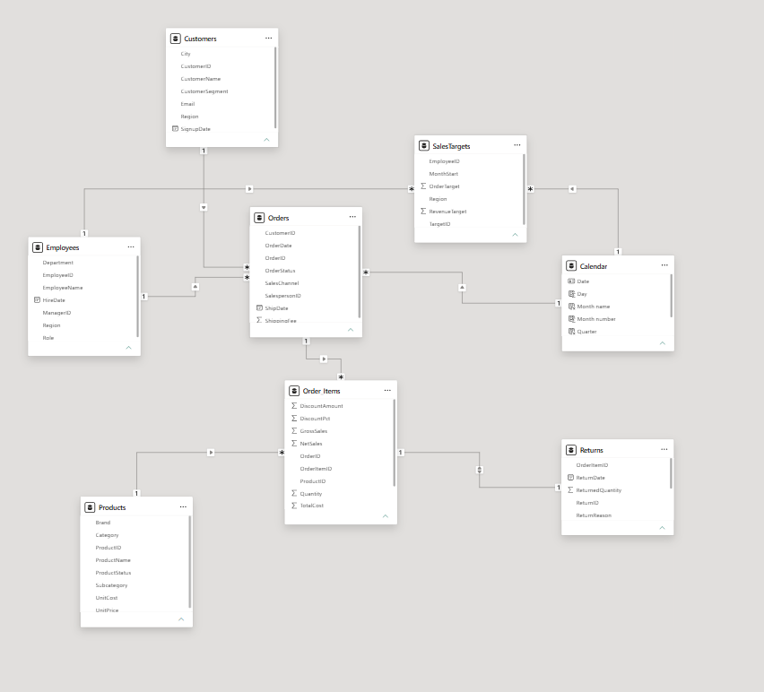
6. Important Data Modeling Considerations
- Orders contains order-header information, while Order_Items contains individual order lines. Their different levels of detail must be considered when calculating totals.
- ManagerID can contain null values when an employee has no assigned manager.
- ShipDate nulls and ShippingFee zero values were retained rather than automatically replaced.
- Sales target calculations must be validated at monthly, employee, regional, and total levels.
- Returns is a sampled synthetic dataset. Return metrics must be interpreted carefully and should not be treated as precise real-world benchmarks.
Day 2 – DAX Measures, Time Intelligence, Advanced Analysis and Data Validation
1. Day 2 Objective
The objective of Day 2 was to create DAX measures, perform time-based sales analysis, analyze business performance, and validate the calculated results against the source data. The goal was to ensure that the measures worked correctly under different filters and reporting conditions.
2. Core DAX Measures
Created the following DAX measures to calculate sales, profitability, orders, discounts, targets, and returns.
Measure | DAX Formula
Net Sales | Net Sales = SUM(Order_Items[NetSales])
Gross Sales | Gross Sales = SUM(Order_Items[GrossSales])
Discount Amount | Discount Amount = SUM(Order_Items[DiscountAmount])
Total Cost | Total Cost = SUM(Order_Items[TotalCost])
Gross Profit | Gross Profit = [Net Sales] - [Total Cost]
Gross Margin % | Gross Margin % = DIVIDE([Gross Profit], [Net Sales])
Units Sold | Units Sold = SUM(Order_Items[Quantity])
Orders | Orders = DISTINCTCOUNT(Orders[OrderID])
Average Order Value | Average Order Value = DIVIDE([Net Sales], [Orders])
Revenue Target | Revenue Target = SUM(SalesTargets[RevenueTarget])
Target Attainment % | Target Attainment % = DIVIDE([Net Sales], [Revenue Target])
Returned Units | Returned Units = SUM(Returns[ReturnedQuantity])
These measures were used to evaluate overall sales performance, profitability, discounts, order volume, target achievement, and returned quantities.
3. Time Intelligence Analysis
Created additional measures to compare sales performance across different time periods.
3.1 Previous Year Sales
Previous Year Sales =
CALCULATE(
[Net Sales],
SAMEPERIODLASTYEAR('Calendar'[Date])
)
Purpose: Calculates net sales for the corresponding period in the previous year.
3.2 Sales Growth %
Sales Growth % =
DIVIDE(
[Net Sales] - [Previous Year Sales],
[Previous Year Sales]
)
Purpose: Calculates the percentage change in sales compared with the previous year.
3.3 Year-over-Year Revenue
YoY Revenue =
[Net Sales] - [Previous Year Sales]
Purpose: Calculates the difference between current-period sales and previous-year sales.
3.4 Previous Month Revenue
Previous Month Revenue =
CALCULATE(
[Net Sales],
DATEADD('Calendar'[Date], -1, MONTH)
)
Purpose: Retrieves revenue from the previous month for month-to-month comparison.
3.5 Year-to-Date Revenue
YTD Revenue =
TOTALYTD(
[Net Sales],
'Calendar'[Date]
)
Purpose: Calculates cumulative net sales from the beginning of the year through the selected date.
3.6 Previous Year YTD Revenue
Previous Year YTD Revenue =
CALCULATE(
[YTD Revenue],
SAMEPERIODLASTYEAR('Calendar'[Date])
)
Purpose: Compares year-to-date revenue with the corresponding period in the previous year.
4. Discount and Return Analysis
4.1 Discount Percentage
Discount % =
DIVIDE([Discount Amount], [Gross Sales])
This measure calculates the discount amount as a percentage of gross sales.
4.2 Return Rate %
Return Rate % =
DIVIDE([Returned Units], [Units Sold])
This project uses a unit-based return rate, calculated as returned units divided by units sold. It is not an order-based return rate.
The returned-unit measure was used to analyze the quantity of products returned. The return rate was approximately 3.28% in the overall report, based on the displayed measures.
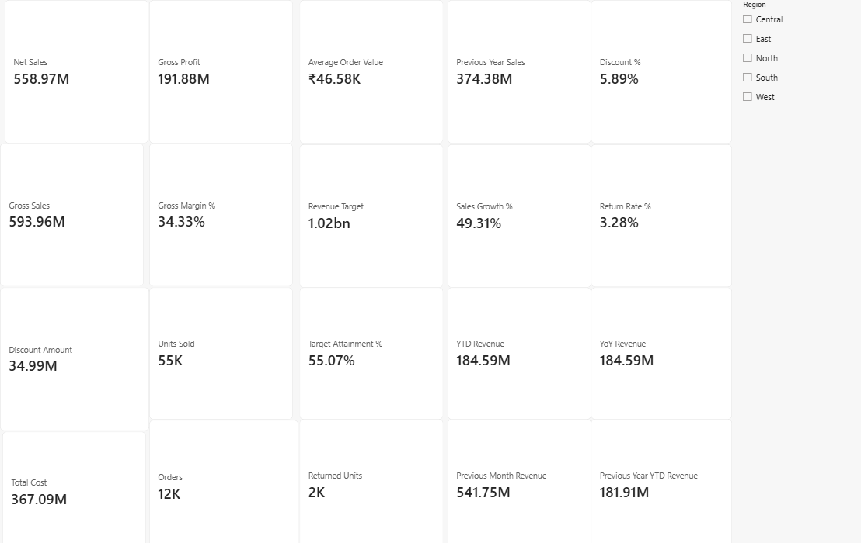
5. Sales Performance and Target Analysis
Actual net sales were compared with revenue targets using the Revenue Target and Target Attainment % measures.
The analysis included:
- Comparing monthly sales with previous-month and previous-year performance.
- Comparing net sales across regions.
- Reviewing actual sales and targets by employee.
- Checking target attainment across months and regions.
- Identifying the strongest and weakest months based on net sales.
The overall target attainment displayed in the report was approximately 55.07%.
During validation, it was observed that using SalesTargets[Region] did not filter sales as expected in a regional matrix. Using Employees[Region] correctly filtered employee-related sales and produced regional sales results. This highlighted the importance of choosing the appropriate dimension field for report filtering.
6. Product Profitability Analysis
Created a product analysis matrix using category and subcategory fields from the Products table.
The matrix included:
- Net Sales
- Gross Profit
- Gross Margin %
This analysis helped compare product categories and subcategories based on their sales contribution and profitability.
The overall gross margin displayed in the report was approximately 34.33%.
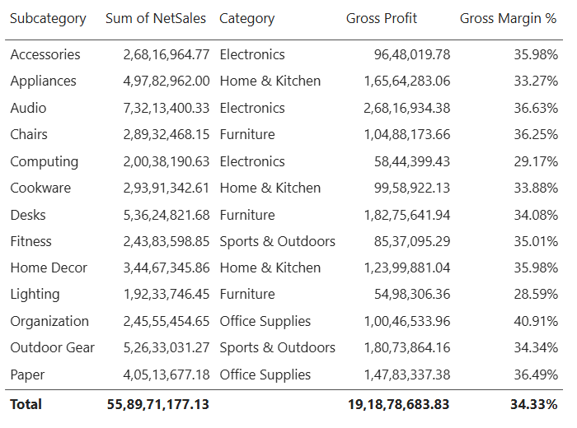
7. Customer Insights
Created a customer analysis table using customer ID, customer name, and the distinct order count.
A repeat customer was defined as a customer who placed more than one distinct order.
The analysis helped identify customers with multiple orders and compare their purchasing frequency. This provides a basis for understanding repeat purchasing behavior.
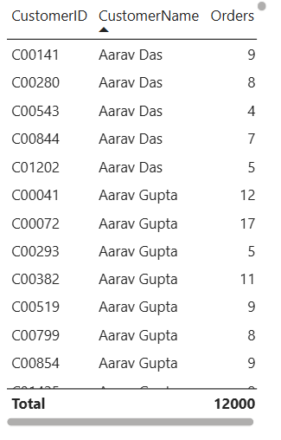
8. Sales Team Performance
Created an employee performance table using employee ID, net sales, and gross profit.
The table was sorted by net sales to identify higher-performing employees. Employee performance was also reviewed alongside revenue targets to understand sales contributions and target achievement.
9. Monthly Revenue Analysis
Created a monthly table using Calendar[Year-Month], Net Sales, and Previous Month Revenue.
The results were checked to confirm that:
- The first available month had no previous-month revenue.
- February 2023 displayed January 2023 revenue as its previous-month value.
- Monthly values changed according to the selected reporting period.
The strongest and weakest months identified by sorting net sales were:
Performance | Month | Net Sales
Strongest month | May 2023 | ₹1,79,60,170.74
Weakest month | February 2025 | ₹1,27,95,886.24
These results are based on the monthly sales values reviewed during the project.
10. Data Validation and Reconciliation
Validated the main sales measures using Power BI cards, tables, source-data totals, and filter testing.
The following results were observed in the overall report:
Metric | Validated Report Result
Net Sales | Approximately ₹55.89 crore
Gross Profit | Approximately ₹19.19 crore
Gross Margin % | 34.33%
Total Orders | 12,000
Returned Units | 1,802
Target Attainment % | 55.07%
Return Rate % | 3.28%
The overall report totals were checked with the regional filter cleared. A South-region selection had previously reduced the displayed totals, demonstrating that slicers affect the filter context of the measures.
Gross Sales, Discount Amount, and Total Cost were also reviewed against source-data totals during the reconciliation process.

Day 3 – Report Development and Dashboard Design
1. Objective
The objective of Day 3 was to develop the report pages for the Retail Sales Analytics project using Power BI. After completing data cleaning, data modeling, DAX measures, and analytical calculations on the previous days, I started converting the prepared data into meaningful visual reports.
The main goal was to present sales performance, profitability, customer behavior, product performance, employee performance, and returns in a clear and understandable format.
2. Report Page Development
I created seven report pages to analyze different aspects of the retail business.
2.1 Executive Overview
I created the Executive Overview page to show the overall business performance. I added KPI cards for Net Sales, Gross Profit, Gross Margin, Orders, Units Sold, Average Order Value, and Target Attainment.
I included charts for monthly sales trends, sales by category, and sales by region. I also added slicers for date, region, sales channel, and customer segment to filter the report easily.
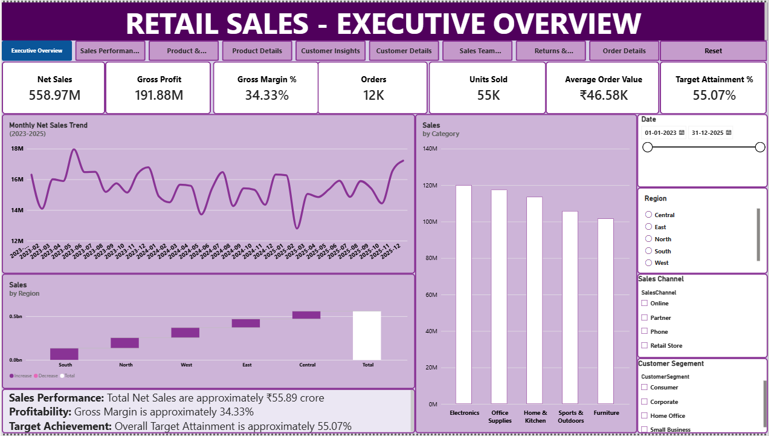
2.2 Sales Performance and Target
I created this page to compare current sales with previous-year sales and revenue targets. I added charts for monthly sales trends, sales by channel, actual sales versus targets by region, and order status.
I also included KPI cards for Target Variance and Target Attainment, along with slicers for sales channel, month, year, and region.
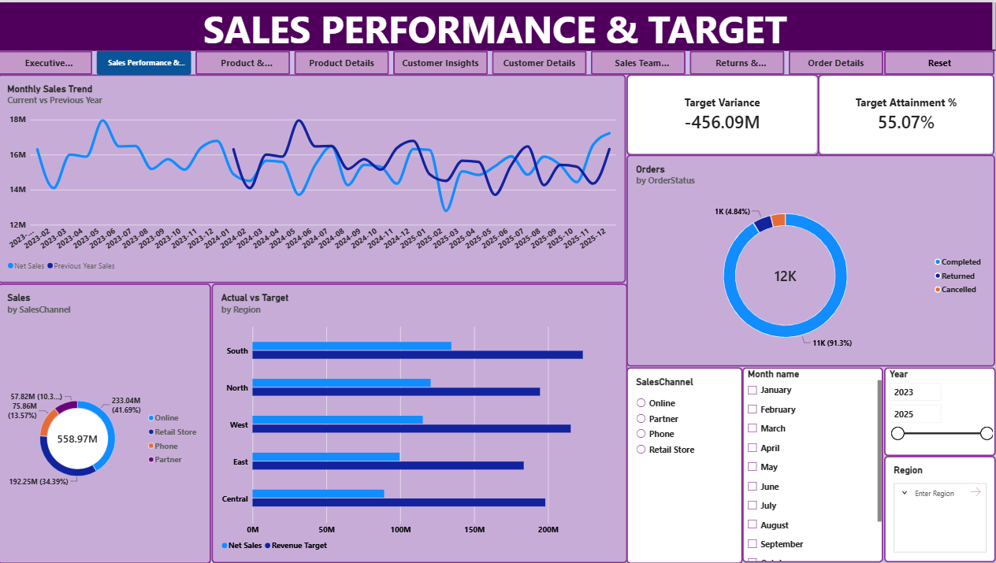

2.3 Product and Category Analysis
I created this page to analyse product sales and profitability. I added KPI cards for Units Sold, Discount Amount, Gross Profit, and Gross Margin %. I also included charts showing Net Sales and Gross Profit by subcategory, along with the Top 10 and Bottom 10 products based on Net Sales.
I added product and category slicers to make it easier to analyse specific products.
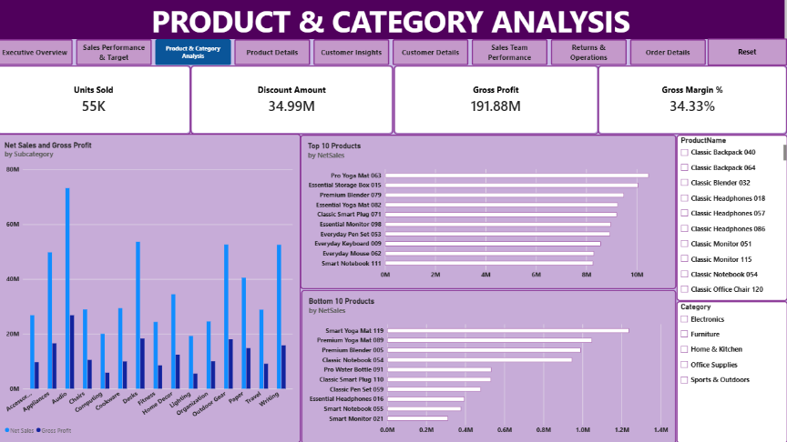
A Product Details page was included to allow more detailed analysis of individual products.
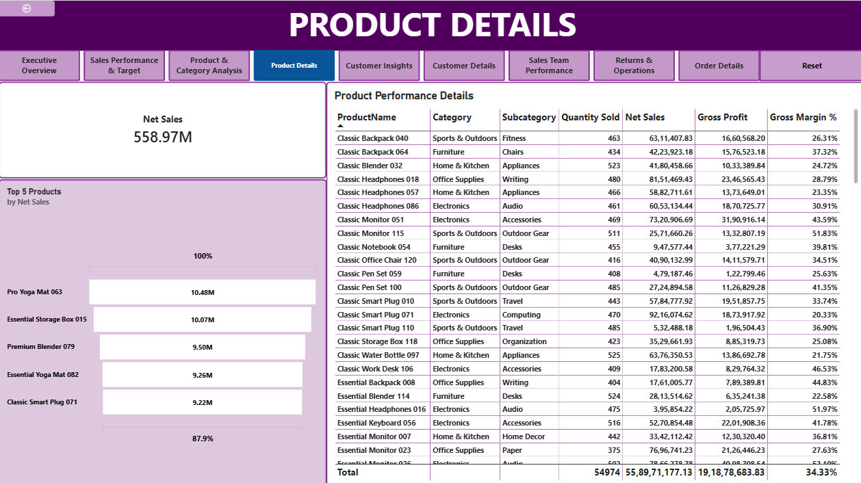
2.4 Customer Insights
I created this page to understand customer purchasing behavior. I added KPI cards for Repeat Customers and Average Orders per Customer. I also included a matrix table showing sales by customer segment and region, a chart showing sales contribution by segment, and a treemap highlighting individual customers by Net Sales.
I added customer segment and region filters to make the analysis easier.
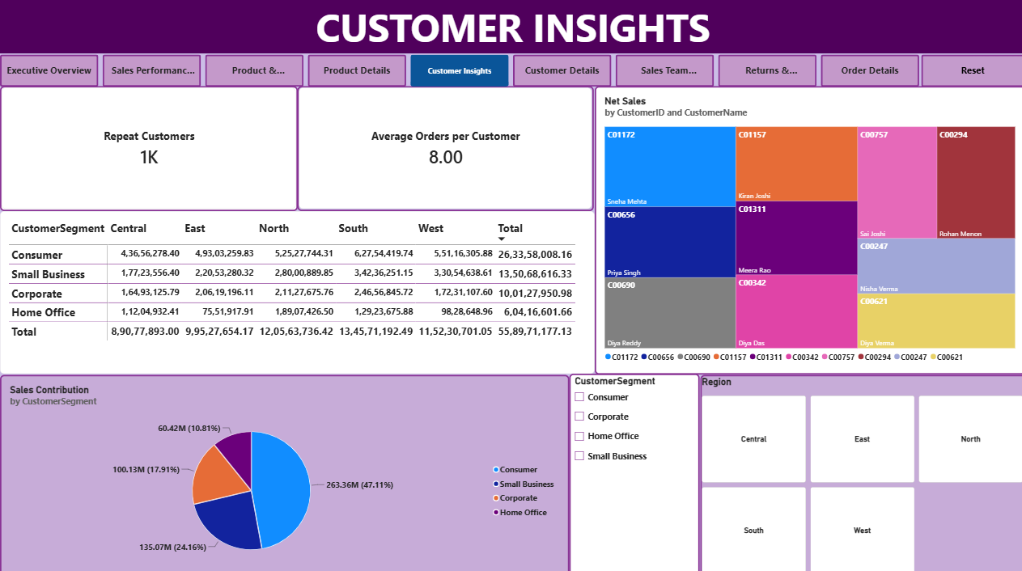
A Customer Details page was included to allow more detailed analysis of individual customers.
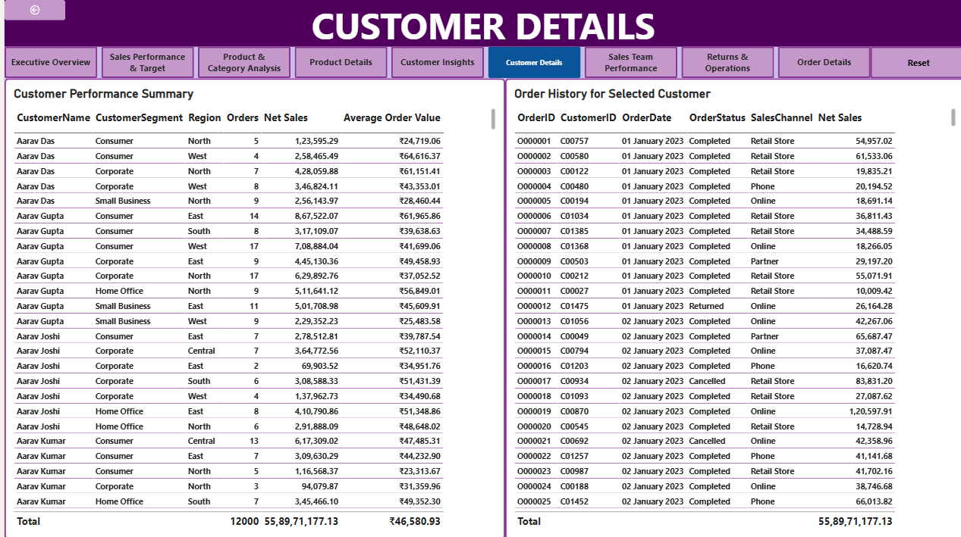
2.5 Sales Team Performance
I created this page to compare employee sales and profit performance. I added KPI cards for Net Sales, Gross Profit, Target Attainment, and Target Variance. I also included a chart comparing employee sales and profit, along with a matrix table showing monthly sales against targets.
I added filters for region, role, and manager to analyse employee performance in more detail.
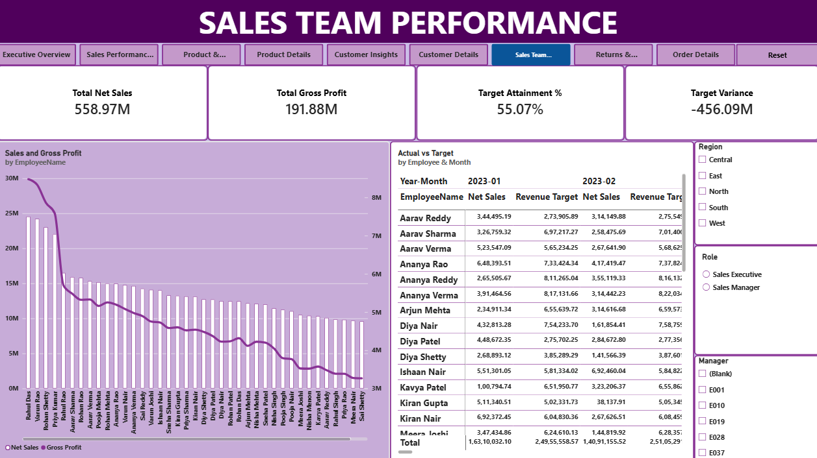
2.6 Returns and Operations
I created this page to analyse product returns and order operations. I added KPI cards for Returned Units, Return Rate %, and Orders. I also included charts showing return reasons, return trends over time, orders by status, and orders by sales channel.
I added filters for date, return reason, and order status. I also included a disclaimer explaining that the return data is synthetic and does not represent actual industry data.
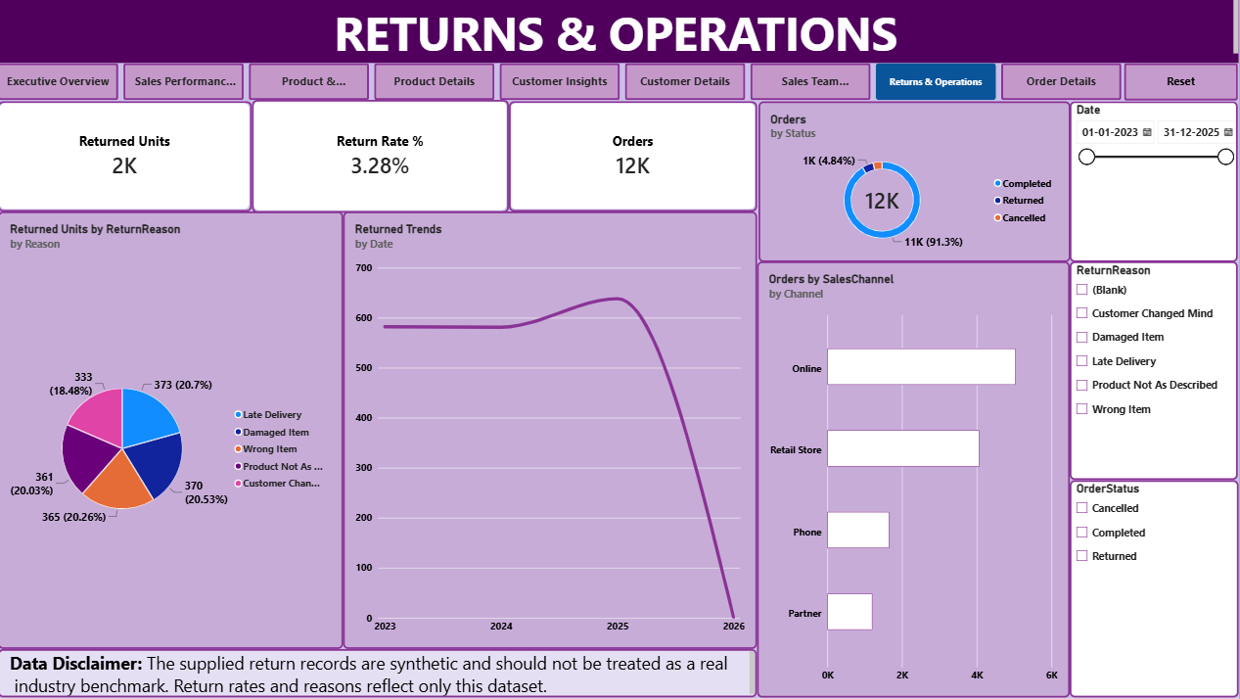

2.7 Order Details
I created this page to view detailed order and product information in one table. It includes order date, order ID, customer name, employee name, sales channel, product name, quantity, discount amount, and Net Sales.
I added filters for order date, sales channel, and order status. I also included a chart showing orders by region to help compare order distribution across regions.
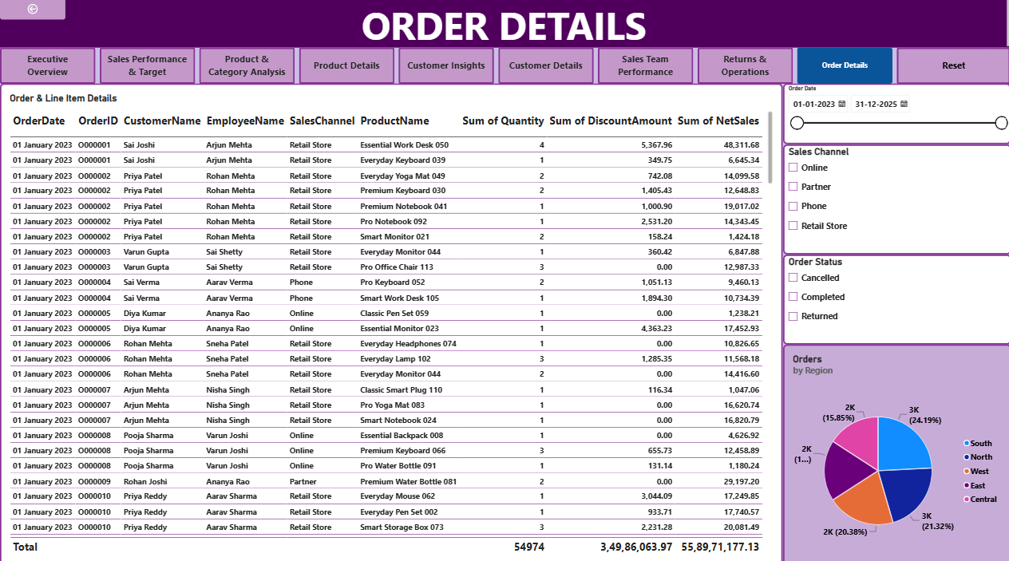
Day 4 – Report Interactivity, Validation and Final Deliverables
1. Objective
The objective of Day 4 was to make the seven report pages interactive, check that the calculations and visuals worked correctly, and organize all the project files into a proper folder structure.
2. Adding Interactive Features
I added slicers, page navigation buttons, and Reset Filters buttons to make the report easier to use. I also used bookmarks to support interactive report views.
3. Drill-Through Pages
I created Customer Details, Product Details, and Order Details pages to help users explore specific information from the main report pages.
4. Region Tooltip
I created a Region Tooltip page to display additional information, including Net Sales, Gross Profit, and Gross Margin %, when users hover over the relevant regional visual. I tested the tooltip to make sure it displayed the expected information.
5. Report Validation
I checked the main calculations against the source data, including Net Sales, Gross Sales, Discount Amount, Total Cost, and Units Sold. I also checked the data relationships and tested the target and return calculations at different levels.
6. Testing Report Functionality
I tested the slicers, Reset Filters buttons, page navigation, drill-through pages, and tooltip. I also reviewed the report layouts, titles, number formats, and visual arrangements.
7. Organizing Final Deliverables
I created a main folder named Retail Sales Analytics - Power BI Capstone and organized the project files into six subfolders:
- 01_Power_BI_Report – Power BI report file (.pbix).
- 02_Data_Model – Data model screenshot.
- 03_Measure_Dictionary – Measure definitions and formulas in Word and PDF formats.
- 04_Validation_Checklist – Validation checklist in Word and PDF formats.
- 05_Project_Summary – Project summary in Word and PDF formats.
- 06_Interview_Preparation – Business questions, project walkthrough, and technical interview questions in Word and PDF formats.
Conclusion:
- I successfully completed my Retail Sales Analytics project using Power BI. I worked on the complete process, starting from data cleaning and data modeling to creating DAX measures and developing seven interactive report pages.
- I used different charts, KPI cards, slicers, drill-through pages, tooltips, and navigation buttons to make the report easy to explore. I also validated the calculations, tested the report features, and organized the final project files and documentation.
- Through this project, I gained practical experience in Power BI, data analysis, dashboard development, and presenting business insights. Although the project uses synthetic data, it helped me understand how business intelligence tools can support better decision-making.
Business Questions Addressed by the Dashboard
1. Executive Performance
- What are the total Net Sales and Gross Profit?
- What is the Gross Margin percentage?
- How many orders were placed and how many units were sold?
- What is the Average Order Value?
- How are the overall business results trending?
2. Time Analysis
- How do sales compare month over month?
- How do sales compare year over year?
- Which months have the highest and lowest sales?
- What is the year-to-date revenue?
3. Products
- Which product categories and subcategories generate the highest sales?
- Which products contribute the most to Gross Profit?
- Which products are the top and bottom performers by sales?
- Where are discounts high or profit margins low?
4. Customers
- Which customer segments and regions contribute the most sales?
- Who are the highest-value customers?
- How many customers make repeat purchases?
- What is the average number of orders per customer?
5. Sales Team
- Which employees and regions perform best?
- Which employees meet or miss their monthly sales targets?
- How do actual sales compare with revenue targets?
- How does employee performance change over time?
6. Operations and Returns
- What percentage of sold units are returned?
- What are the leading reasons for product returns?
- How do returns change over time?
- How are orders distributed by status and sales channel?

